How to Configure Multi-factor Authentication and Connect to VPN

KB0010448





67 views

When working outside of Progressive Leasing's offices, a VPN connection will be required to access internal resources including email. There are two components for connecting to VPN: Multi-factor authentication (MFA) and a VPN client. Multi-factor authentication uses Microsoft Authenticator to verify your credentials in addition to username and password. The VPN client is software that creates a tunnel to Progressive Leasing's network. The aim of this guide is to walk through the steps of setting up MFA, connecting to VPN with the client, and how to manually install and configure the client on Windows, OSX, iOS and Android if required.

|  |
| --- |
| **Contents** |
| 1. [Setup Multi-factor Authentication With Microsoft Authenticator](https://progleasing.service-now.com/kb_view.do?sysparm_article=KB0010448#Setup_Multi-factor_Authentication_With_Microsoft_Authenticator) 2. [Check Point Mobile VPN Client (Windows)](https://progleasing.service-now.com/kb_view.do?sysparm_article=KB0010448#Check_Point_Mobile_VPN_Client_(Windows)) 3. [Check Point Endpoint Security VPN Client (OSX)](https://progleasing.service-now.com/kb_view.do?sysparm_article=KB0010448#Check_Point_Endpoint_Security_VPN_Client_(OSX)) 4. [Check Point Capsule VPN Client (Android and iOS)](https://progleasing.service-now.com/kb_view.do?sysparm_article=KB0010448#Check_Point_Capsule_VPN_Client_(Android_and_iOS)) 5. [Manual Installation and Configuration of Client](https://progleasing.service-now.com/kb_view.do?sysparm_article=KB0010448#Manual_Installation_and_Configuration_of_Client) |

Setup Multi-factor Authentication With Microsoft Authenticator

1. Download Microsoft Authenticator on your phone

* Using your phone's app store, install Microsoft Authenticator. It is available on iPhone, Android and Windows Phone.

Android - <https://play.google.com/store/apps/details?id=com.azure.authenticator> (open links in new window)

iOS - <https://itunes.apple.com/us/app/microsoft-authenticator/id983156458> (open links in new window)

2. Login to Progressive Leasing's MFA website

* Go to <https://mfa.progleasing.com/multifactorauth> and use your computer credentials to login

[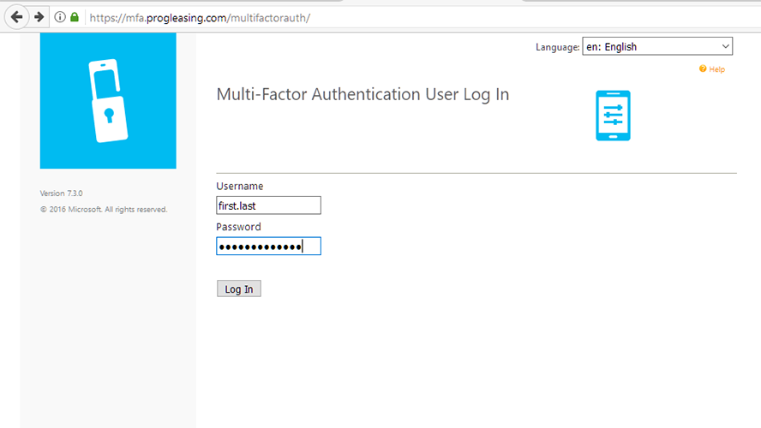](https://progleasing.service-now.com/wiki_page.do?title=image:mfalogin.PNG&sysparm_field=kb_knowledge.wiki&sysparm_kbtable=kb_knowledge)

3. Generate Activation Code

* Click Generate Activation Code

[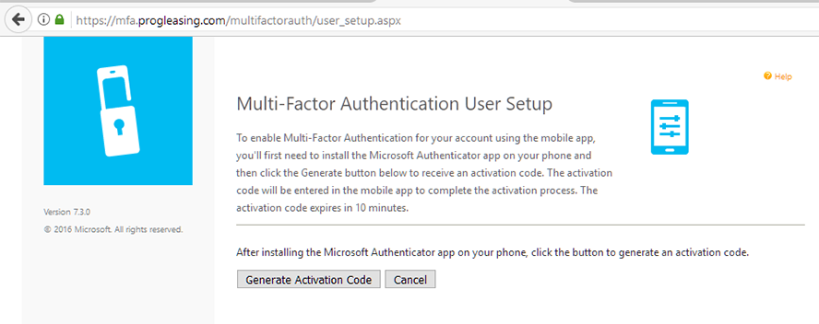](https://progleasing.service-now.com/wiki_page.do?title=image:mfapin.PNG&sysparm_field=kb_knowledge.wiki&sysparm_kbtable=kb_knowledge)

4. Set up application and PIN code

* On your phone, open Microsoft Authenticator and chose Add Account (Android shown) and then "Work or school account".

[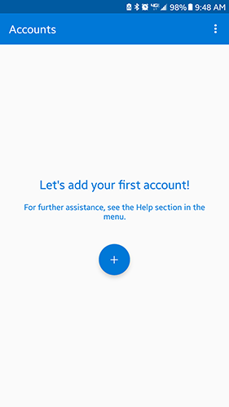](https://progleasing.service-now.com/wiki_page.do?title=image:mfaadd.png&sysparm_field=kb_knowledge.wiki&sysparm_kbtable=kb_knowledge)[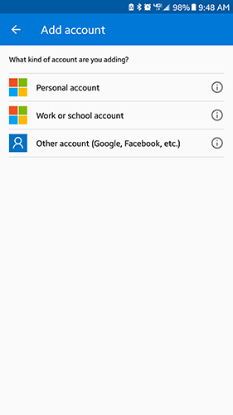](https://progleasing.service-now.com/wiki_page.do?title=image:mfawork.png&sysparm_field=kb_knowledge.wiki&sysparm_kbtable=kb_knowledge)

* With your phone, scan the QR code on the MFA website.

[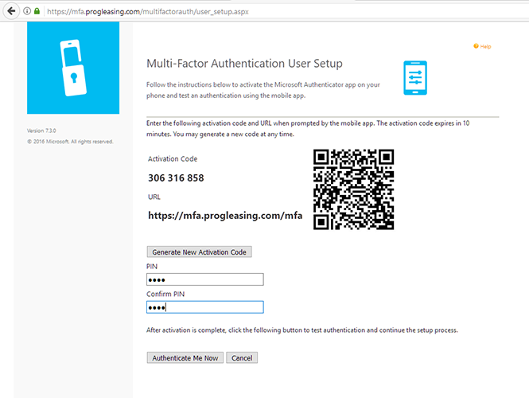](https://progleasing.service-now.com/wiki_page.do?title=image:mfaapp.PNG&sysparm_field=kb_knowledge.wiki&sysparm_kbtable=kb_knowledge)

* After you have scanned the code create a PIN. This is NOT the code shown in Microsoft Authenticator. This is a code you create for verifying your identification.
* Once you have created your PIN click Authenticate Me Now. Microsoft Authenticator will push a notification to your phone requesting authentication. Enter your PIN.

5. Set up security questions

* If you were successful in configuring your PIN and setting up the application, the MFA website will now ask you to create security questions in the event you forget your PIN. Select and answer four questions. All answers will be required to reset your PIN.

[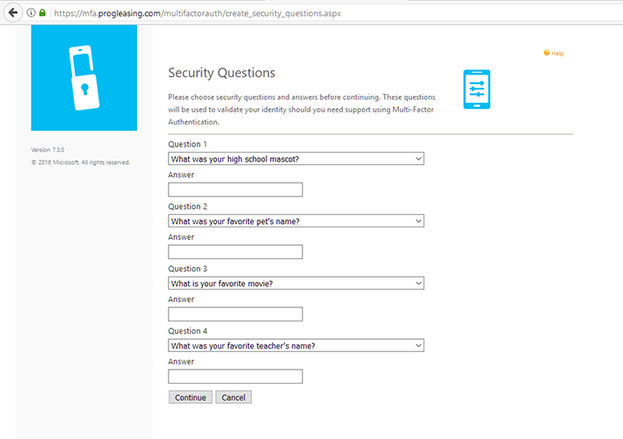](https://progleasing.service-now.com/wiki_page.do?title=image:mfasec.PNG&sysparm_field=kb_knowledge.wiki&sysparm_kbtable=kb_knowledge)

6. Confirmation

* If all steps were successful you will see a confirmation page. Multi Factor Authentication is now configured.

[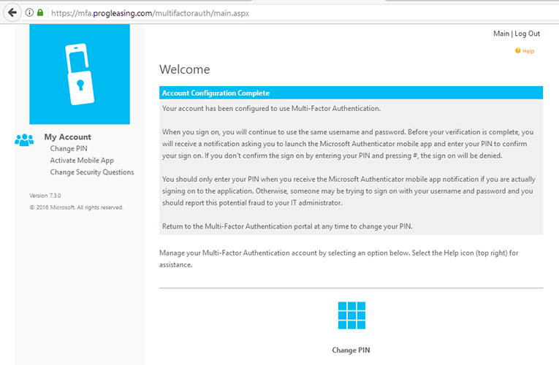](https://progleasing.service-now.com/wiki_page.do?title=image:mfaconf.PNG&sysparm_field=kb_knowledge.wiki&sysparm_kbtable=kb_knowledge)

Check Point Mobile VPN Client (Windows)

If you are using a Windows laptop, Check Point Mobile should be pre-installed and configured. If it is not installed contact the Service Desk.

1. Open the system tray, right click on the Check Point Mobile icon and click Connect

[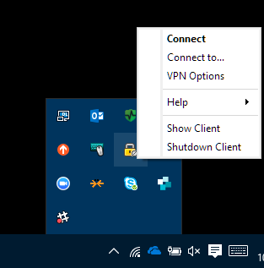](https://progleasing.service-now.com/wiki_page.do?title=image:winicon.PNG&sysparm_field=kb_knowledge.wiki&sysparm_kbtable=kb_knowledge)

2. Enter your credentials and click Connect

[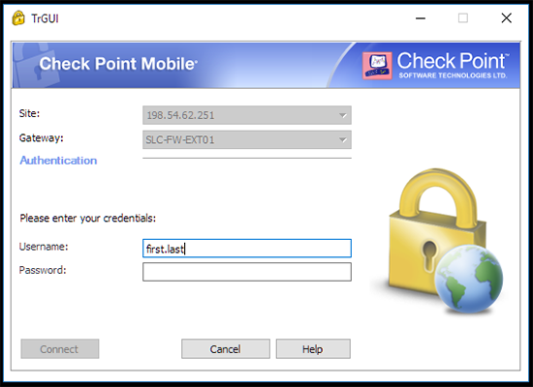](https://progleasing.service-now.com/wiki_page.do?title=image:winlogin.PNG&sysparm_field=kb_knowledge.wiki&sysparm_kbtable=kb_knowledge)

3. A notification will be pushed to Microsoft Authenticator on your phone requesting approval of sign in. Enter your PIN or use your fingerprint to authorize.

4. If multi-factor authentication is successful, you will now be connected to VPN

Check Point Endpoint Security VPN Client (OSX)

If you are using an OSX laptop, Check Point Endpoint Security can be downloaded here: <https://progleasing.service-now.com/sys_attachment.do?sys_id=b5bb632713fd43c48242335fd144b07a>

To allow the installation, run the Endpoint Security Installer then go to System Preferences>Security & Privacy and under the "Allow apps downloaded from:" section click Open Anyway. Proceed with install.

**Connecting**

1. Click the Check Point Endpoint Security VPN icon and choose Connect

[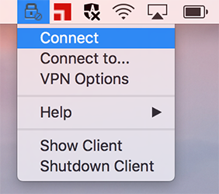](https://progleasing.service-now.com/wiki_page.do?title=image:osxconnect.png&sysparm_field=kb_knowledge.wiki&sysparm_kbtable=kb_knowledge)

2. Enter your credentials and click Connect

[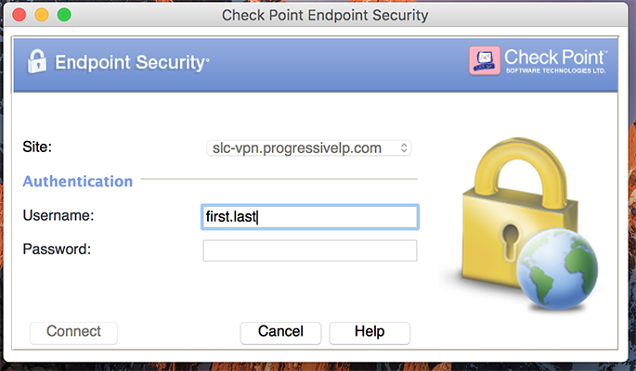](https://progleasing.service-now.com/wiki_page.do?title=image:osxlogin.png&sysparm_field=kb_knowledge.wiki&sysparm_kbtable=kb_knowledge)

3. A notification will be pushed to Microsoft Authenticator on your phone requesting approval of sign in. Enter your PIN or use your fingerprint to authorize.

4. If multi-factor authentication is successful, you will now be connected to VPN

Check Point Capsule VPN Client (Android and iOS)

For VPN access on mobile phones and tablets running Android or iOS, download Check Point Capsule

Android – <https://play.google.com/store/apps/details?id=com.checkpoint.VPN> (open links in new window)

iOS - <https://itunes.apple.com/us/app/check-point-capsule-connect/id506669652> (open links in new window)

1. After downloading and installing Capsule, create a new site using the following settings:

* Server name: slc-vpn.progressivelp.com
* Accept server's trust certificate
* Authentication Method: Username and Password

[](https://progleasing.service-now.com/wiki_page.do?title=image:capsite.png&sysparm_field=kb_knowledge.wiki&sysparm_kbtable=kb_knowledge)[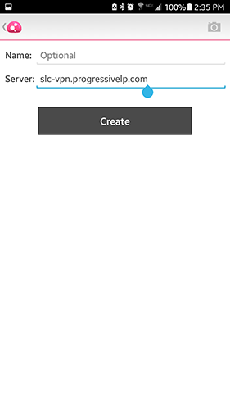](https://progleasing.service-now.com/wiki_page.do?title=image:capserver.png&sysparm_field=kb_knowledge.wiki&sysparm_kbtable=kb_knowledge)[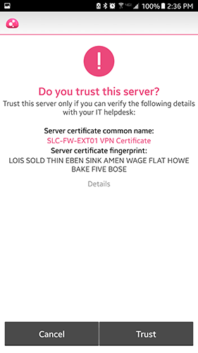](https://progleasing.service-now.com/wiki_page.do?title=image:captrust.png&sysparm_field=kb_knowledge.wiki&sysparm_kbtable=kb_knowledge)[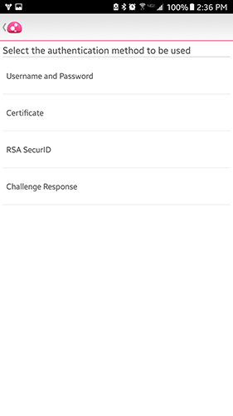](https://progleasing.service-now.com/wiki_page.do?title=image:capusername.png&sysparm_field=kb_knowledge.wiki&sysparm_kbtable=kb_knowledge)[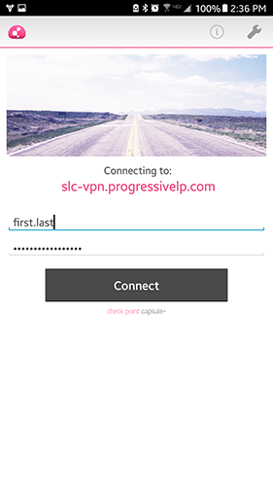](https://progleasing.service-now.com/wiki_page.do?title=image:capconnect2.png&sysparm_field=kb_knowledge.wiki&sysparm_kbtable=kb_knowledge)

6. Enter credentials and hit connect. A notification will be pushed to Microsoft Authenticator on your phone requesting approval of sign in. Enter your PIN or use your fingerprint to authorize.

7. If multi-factor authentication is successful, you will now be connected to VPN

Manual Installation and Configuration of Client

If you do not have the Check Point VPN client installed on your computer you can install and configure it yourself

1. Download the VPN client

Windows - <https://supportcenter.checkpoint.com/supportcenter/portal/user/anon/page/default.psml/media-type/html?action=portlets.DCFileAction&eventSubmit_doGetdcdetails=&fileid=55515>

OSX - <https://supportcenter.checkpoint.com/supportcenter/portal/user/anon/page/default.psml/media-type/html?action=portlets.DCFileAction&eventSubmit_doGetdcdetails=&fileid=52910>

2. Install the client using default settings

3. Right click on Check Point VPN icon and click Connect. Configure a new site.

[](https://progleasing.service-now.com/wiki_page.do?title=image:winicon.PNG&sysparm_field=kb_knowledge.wiki&sysparm_kbtable=kb_knowledge)[](https://progleasing.service-now.com/wiki_page.do?title=image:osxconnect.png&sysparm_field=kb_knowledge.wiki&sysparm_kbtable=kb_knowledge)

4. In the Site Wizard, use the following settings

* Server address or Name: slc-vpn.progressivelp.com
* Accept server's trust certificate
* Authentication Method: Username and Password

5. After configuring the VPN, connect and authorize login with Microsoft Authenticator

6. Turn off Always-Connect by right clicking on the Check Point VPN icon and then VPN Options. Click Properties. On the Settings tab uncheck the "Enable Always-Connect" box.

[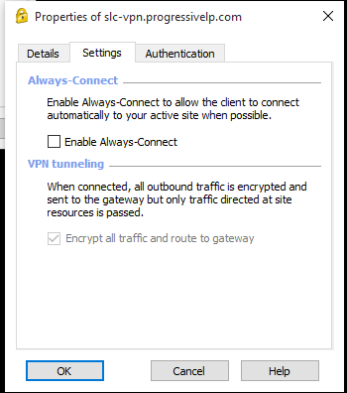](https://progleasing.service-now.com/wiki_page.do?title=image:capalways2.png&sysparm_field=kb_knowledge.wiki&sysparm_kbtable=kb_knowledge)

Authored by Tedson Willard

Last modified 05/21/2018 08:33:56